venv interpriter path of python

D:\python\my_practice\pythonProject\nopecommaerceApp\venv\Scripts\python.exe

To active virtual environment in terminal/ cmd window use this command

venv\Scripts\Activate.ps1

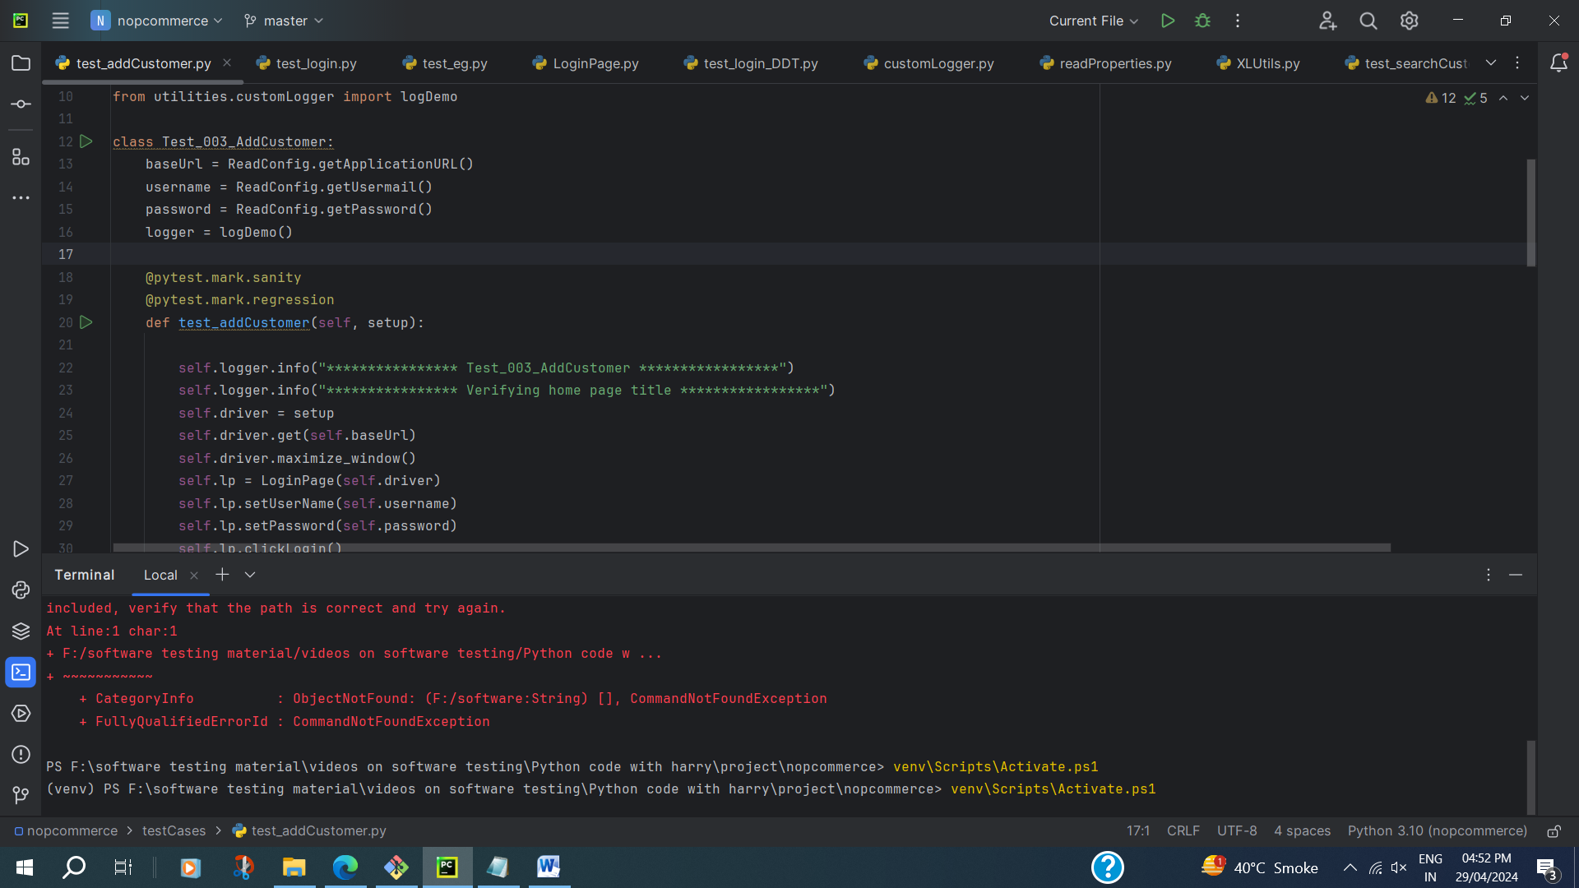

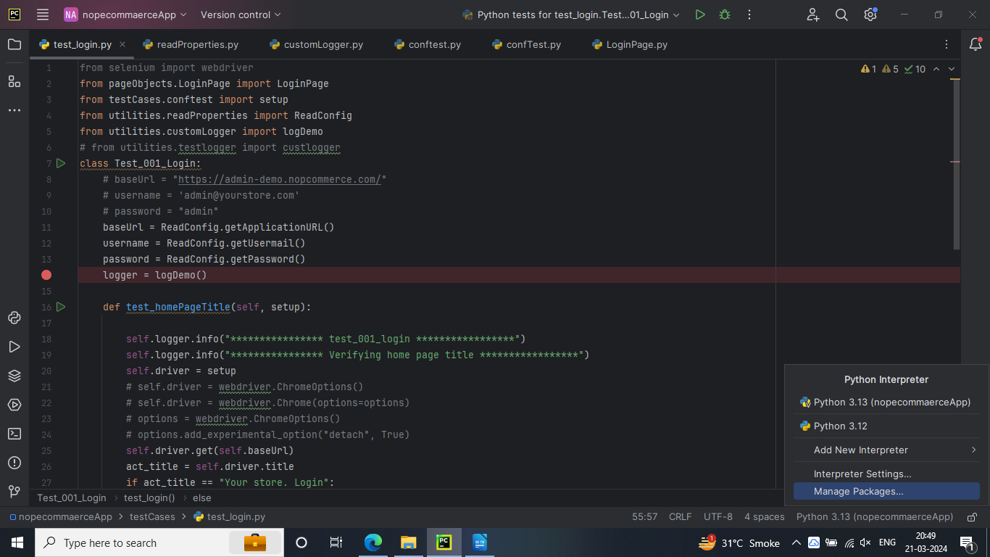

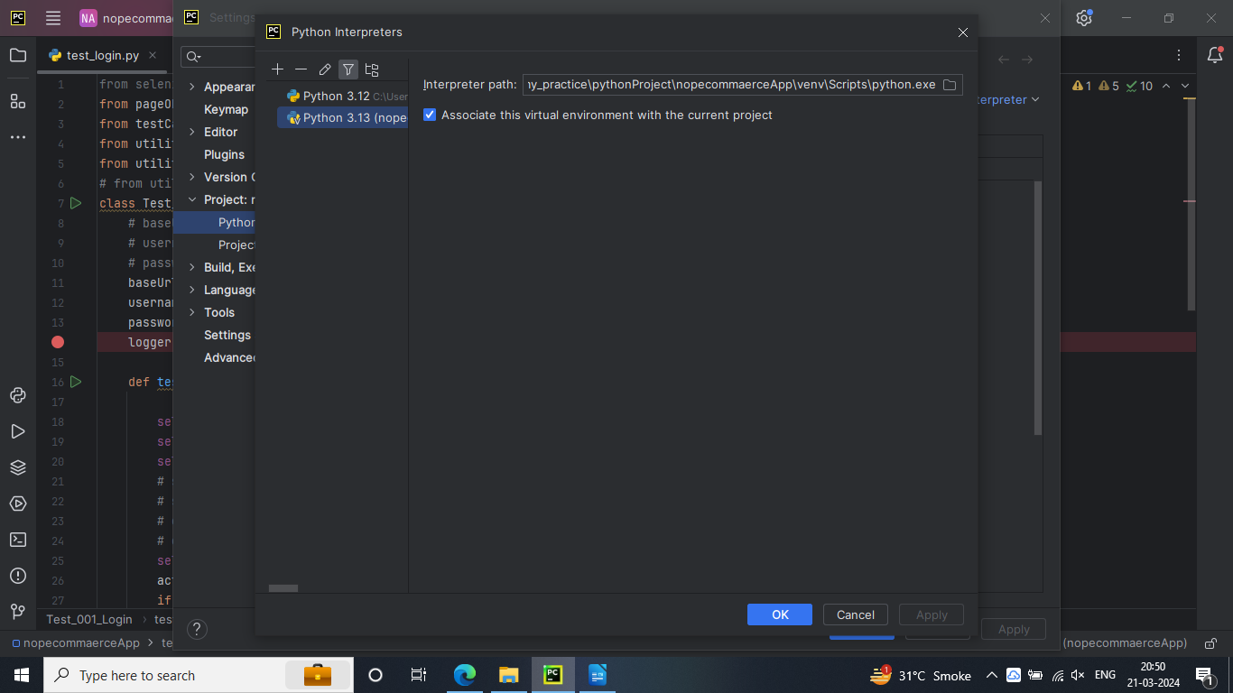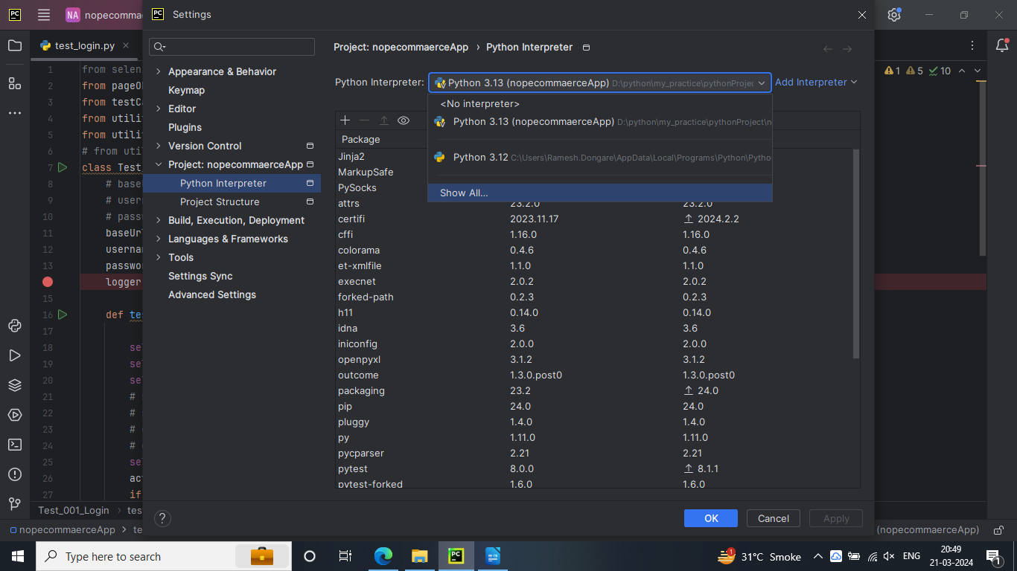

Run.bat file is not running

